**ECON 136: Week 5, Monday**

Sit next to someone who uses similar computer software to you.

My goal: Raising your comfort level in thinking about preferences and the gains from exchange

Who are we?

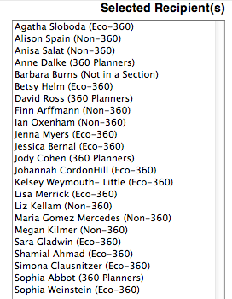

A) Working with Indifference Curves

1) Using the information in the diagram, illustrate how David’s preferences exhibit a diminishing marginal rate of substitution of wood from shortbread by comparing the amount of shortbread he would be willing to give up to increase his wood from 1.5 to 2 cords with the shortbread he would give up to gain 0.5 cords when he already has 3.

2) Now do the same exercise for John’s preferences.

3) Describe a plausible voluntary exchange between David and John (one that would make both better off and from which neither could gain without making the other worse off). Illustrate the outcome on this diagram. (Only go back to your notes from Wednesday’s class of you find you need some help.)



4) If you and your partner finish before the rest of us are ready to move on, then discuss any obstacles or uncertainty you have run into in tackling Wednesday’s opportunity cost assignment.

B) The Gains from Specialization

John and David can be better off if they recognize that each has different opportunity costs in production. David is relatively better at producing shortbread and John is **relatively** better at producing wood.

David

John

If John specializes in producing wood, and David in shortbread, then they can move from a (5,2.75) economy to a (6, 3.5) economy and both be better off.

If John is producing 6 cords of wood and David 3.5 dozen shortbread cakes, now there is a lens of trading opportunities between the consumption bundles (hence utility levels) they achieved through their previous bargain which left

David at (4,1.25) and John at (1,1.5)

An exchange equilibrium for this economy has David producing 3.5 dozen shortbread cakes, John producing 6 cords of wood, David consuming 4.5 cords of wood and 20 shortbread cakes (1.75 dozen), and John consuming 1.5 cords of wood and 16 shortbread cakes (1.25 dozen)



C) How do you react to each of these “voluntary exchanges”

1) David/John – Shortbread/Wood

2) *Birds of America* auctions

<http://online.wsj.com/news/articles/SB10001424052748704250704576005751646141670>

<http://upload.wikimedia.org/wikipedia/commons/5/50/Zenaida_macrouraAWP17AA.jpg>

<http://digital.library.pitt.edu/a/audubon/>

3) International exchanges represented or implied in the Shonibare exhibit

<http://www.barnesfoundation.org/about/press/media-info/shonibare-release>

<http://www.wmagazine.com/culture/art-and-design/2014/01/yinka-shonibare-barnes-foundation/photos/>